Group Work #1: Stanley Lu (sl9p9) and Thomas Dolan (tjddhd)

Part 1: Relationships

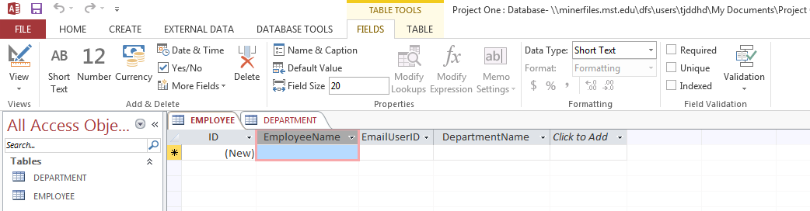

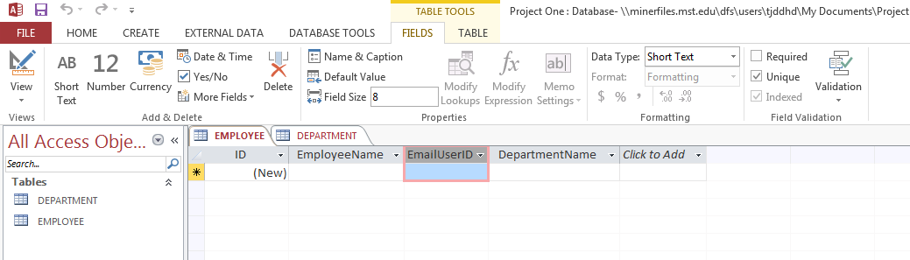

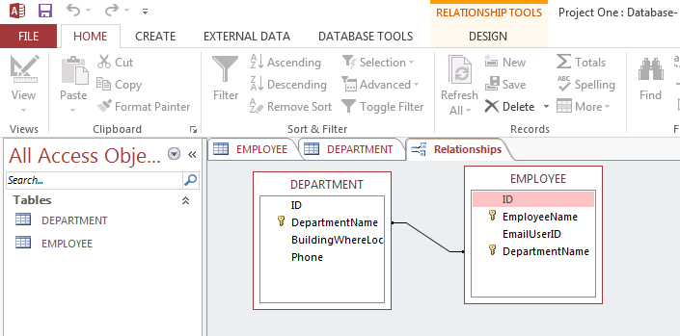

Part 2: Data

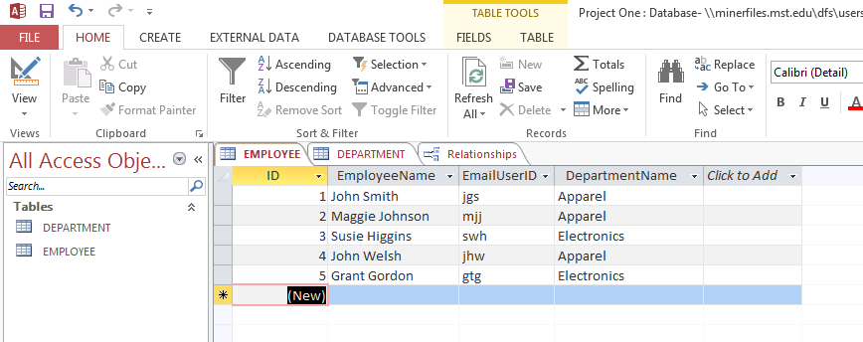

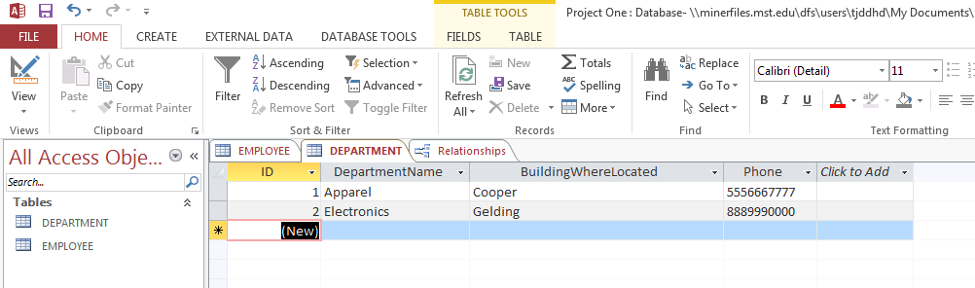

Part 3: Form Wizard

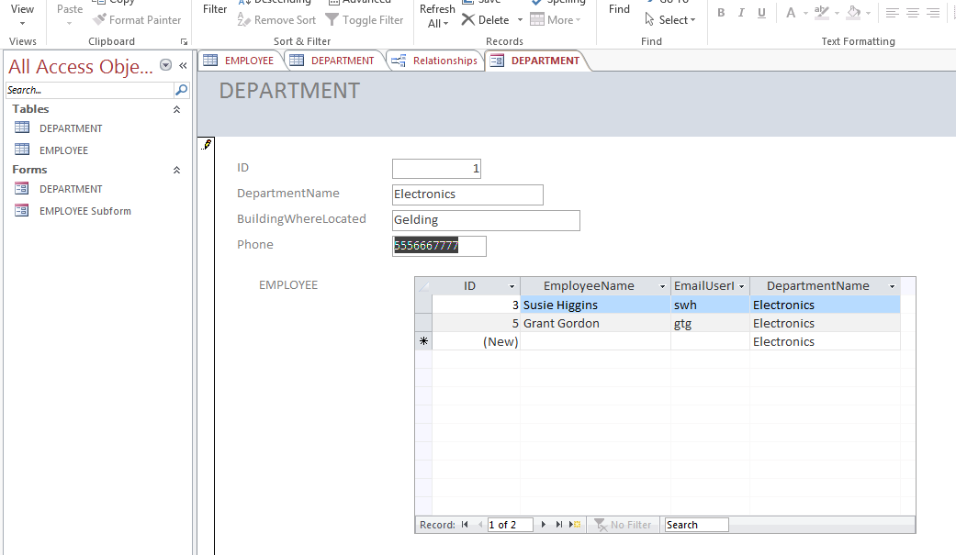

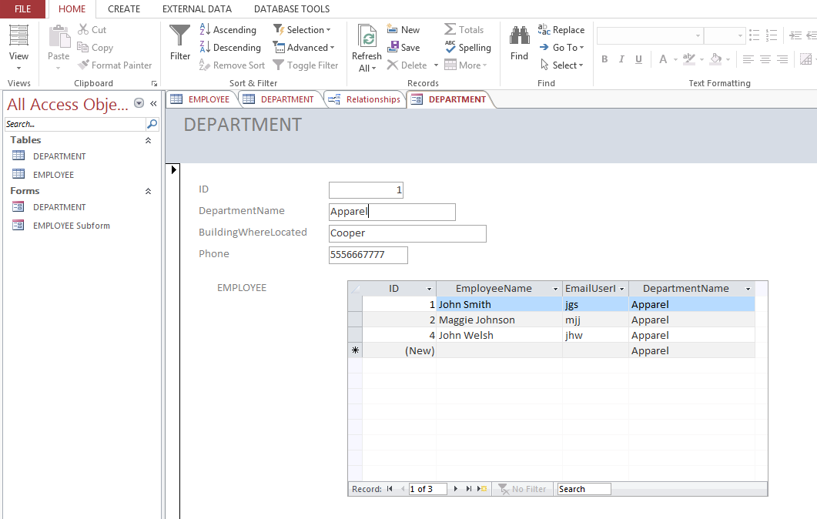

Part 4: Report Wizard

